Rainbow Report General Information

The Rainbow report can also be accessed from the public agenda’s of the ICOC meetings located here:
https://go.boarddocs.com/ca/sandi/Board.nsf/goto?open&id=CDHR296BBDCC
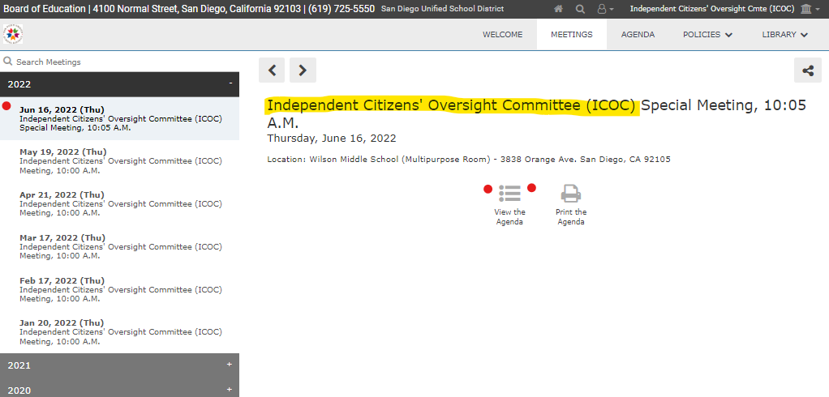
Under the “Meetings” tab, you’ll have access to all previous meetings and select the date to and click the agenda:
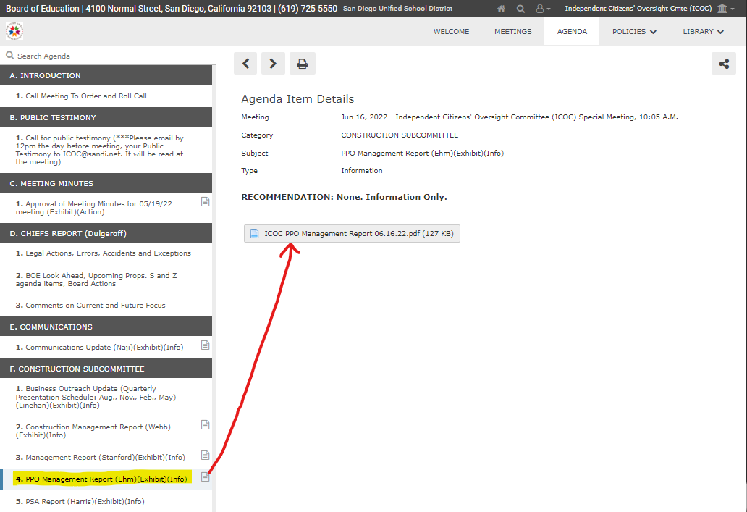
Under section F. Construction Subcommittee item 4. PPO Mgt. Report, select the paper icon to populate the report, click to open
